Circle Language Spec: Commands

Target Command Definition in a Diagram
The concept of target command definitions is explained in the article Target Command Definition. This article only explains its expression in a diagram.

To find the target definition, you first follow all the object redirections, then one class redirection, then all the object redirections and there it ends.

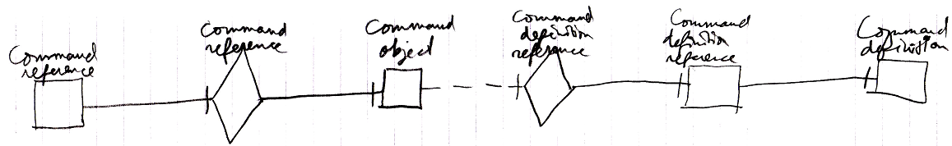

It does not matter if whether it is a diamond, that can be executed, or a square, that can not be executed.

If the definition has a definition as well, this does not redirect the original command object’s definition, because the second definition is another definition object, that the first definition is just based on. An object redirection is just a much tighter bond, than a class redirection.

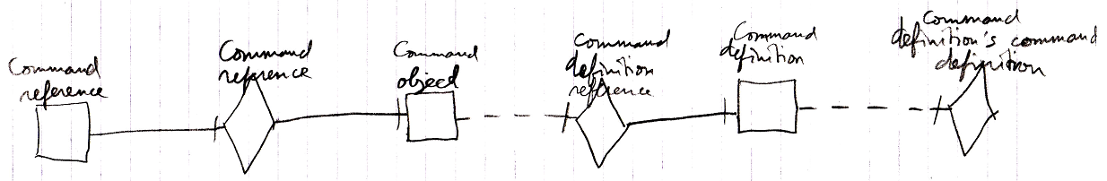

The target definition of the first object reference is the symbol Command Definition, not the symbol Command definition’s command definition. The same counts for the diagram below.

